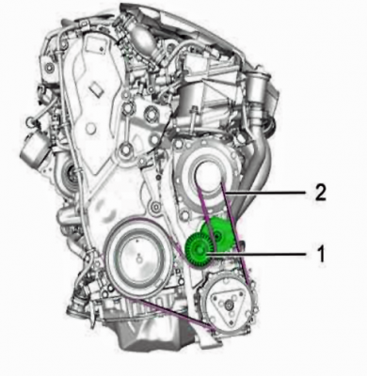
Refit the ancillary belt (2), checking that the belt is correctly fitted in the grooves of the different pulleys and if re-using the old belt, ensure that it is refit in the correct fitting direction.
Remove the peg [0188-Q1]; Using tool [0188-Z].
Refit:
- The front right mud guard
- The front right wheel
- The protective panel under the engine
Part Two: Timing Belt
Tools Used: Refer to Previous Post
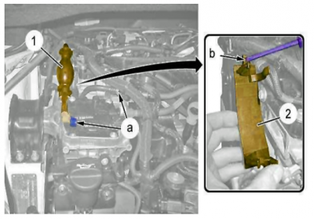 | 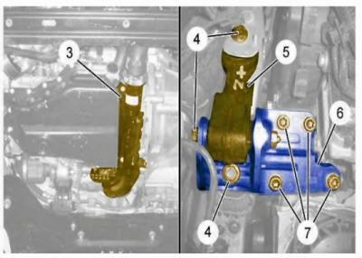
During removal: Plug the fuel low pressure supply pipes; Using the plugs [1617-J].  - Uncouple the unions of the fuel low pressure circuit (at "a").  - Unclip and move aside the manual priming pump (1).  - Remove the mounting of the diesel fuel manual primer pump (2) ; By means of a screwdriver (at "b"). | Remove the air union (3)  CAUTION: Use a rubber shim of sufficient surface area to avoid distorting the engine oil sump (Risk of obstruction of the oil pump suction strainer.)  Support the engine using a jack and a soft block (Timing gear side).  Remove:  - The mountings (4)  - The bolts (7)  - The engine supports (5) and (6)
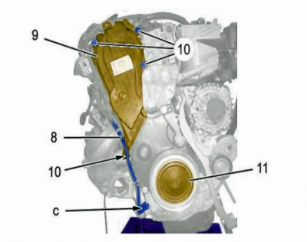 | 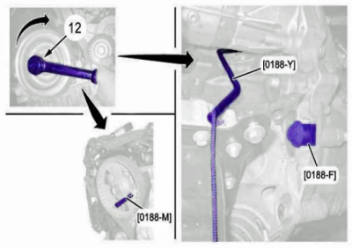
Disconnect the connector of the engine speed sensor (at "c").  Release and move aside the electrical harness (8).  Remove:  - The pulley cover (11)  - The bolts (10)  - The top timing cover (9) | CAUTION: It is essential to rotate the engine by means of the bolt (12) and in the clockwise direction only.  Peg:  - The camshaft pulley ; Using tool [0188-M]  - The flywheel ; Using tool [0188-Y]  Lock the flywheel using the retainer [0188-F].
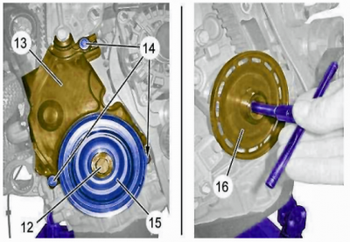 | 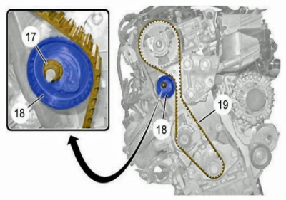
CAUTION: The target (16) must show no trace of damage and no magnetic source must go near it.  CAUTION: Use of an impact wrench is prohibited (Risk of the bolt (12) breaking in the crankshaft)  Remove:  - The bolt (12) and its spacer  - The crankshaft pulley (15)  - The engine speed sensor target (16)  - The 3 bolts (14)  - The timing cover (13)  Clean the crankshaft thread with a M14x150 thread cutter. | Unscrew nut (17).  Detension the dynamic tensioner roller (18).  Remove the timing belt (19).
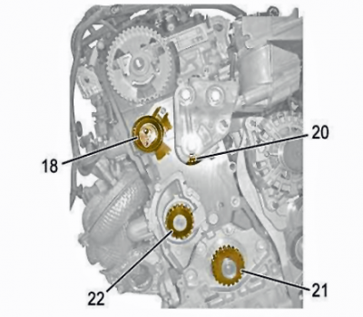 | 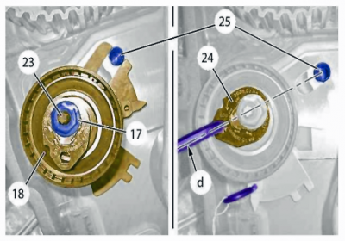
Verification  Check that the following components rotate freely (Absence of play and points of resistance):  - Dynamic roller tensioner (18)  - Roller tensioner (20)  - Crankshaft pulley (21) on keyways  - Water pump pulley (22)  Visually check:  - That there is no trace of an oil leak  - That there are no coolant leaks  - That there is no rubbing on the timing covers  CAUTION: Replace any defective parts. | Dynamic Roller Tensioner  CAUTION: The operations for replacing and adjusting the tension of the dynamic tensioner roller (18) are performed with the aid of a mirror.  Replacement  CAUTION: Do not release the new dynamic tensioner roller (18) without having refitted the timing belt (19).  Remove:  - The nut (17)  - The stud (23)  - The dynamic roller tensioner (18)  CAUTION: The dynamic tensioner roller (18) should be secured in the cylindrical pin (25).  Refit:  - The dynamic roller tensioner (18) (new) (Locked)  - The stud (23)  - The nut (17) ; Finger tighten  - Align the eccentric (24) on the axis "d" ; Using a hexagonal spanner
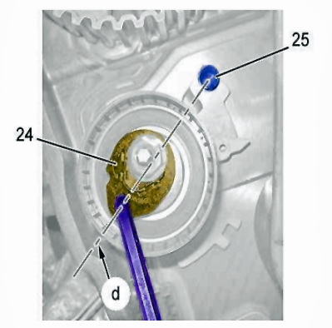  C5 X7 DW10CTED4 Timing Belt 9.PNG (181.25 KiB) Viewed 229 times | 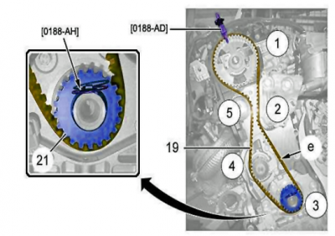
If Re-Used:  CAUTION: The dynamic tensioner roller (18) should be secured in the cylindrical pin (25).  Align the eccentric (24) on the axis "d" ; Using a hexagonal spanner. | Refitting:  CAUTION: Adhere to the tightening torques.  Pre-Tightening The Belt  CAUTION: Always replace the timing belt (19).  - Rotate the crankshaft pulley (21) on its cotter pin; Centre using the tool [0188-AH].  - Fit the timing belt (19) on the camshaft pinion ; Immobilise the pinion ; Using tool [0188-AD].  - Position the timing belt (19) on the pulleys in the order indicated ; Span ("e") of the belt correctly tensioned.  CAUTION: New dynamic roller tensioner (18): Take away the locking pin.
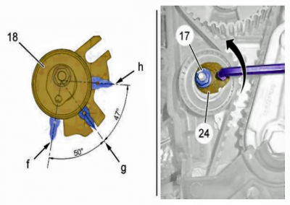 | 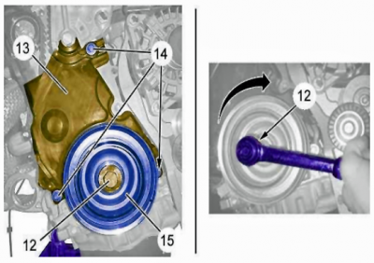
Apply a maximum tension to the timing belt (19):  - Do up the nut (17) by hand  - Rotate the eccentric (24) anti-clockwise  - Bring the index to position "f"  - Tighten the nut (17)  N.B. : The eccentric (24) is close to the horizontal.  Remove the tools [0188-AD], [0188-AH]. | CAUTION: Systematically replace the screw (12); Do not go beyond 5 minutes between pre-tightening and final tightening of the bolt .  Refit:  - The timing cover (13)  - The 3 bolts (14)  - The engine speed sensor target (16)  - The crankshaft pulley (15)  - The bolt (12) and its spacer  Remove the tools [0188-F], [0188-M], [0188-Y].  Turn the engine 6 rotations in the clockwise direction.  Check the position of the timing belt (19).  Peg the assembly with tools [0188-F], [0188-M], [0188-Y].  Slacken the bolt (12) in order to permit the crankshaft pulley to rotate on its keyways.
  Position of the index | State of tension of the timing belt
  "f" | Dynamic roller tensioner (18) at maximum timing belt tension
  "g" | Dynamic roller tensioner (18) at nominal timing belt tension
  "h" | Dynamic roller tensioner (18) at minimum timing belt tension

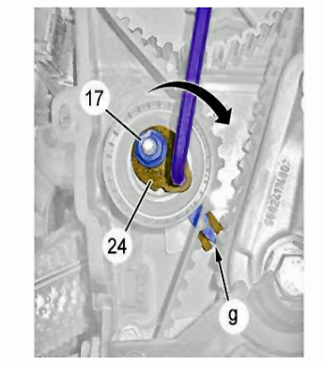
C5 X7 DW10CTED4 Timing Belt 9D.PNG (162.64 KiB) Viewed 229 times
Final Tension
CAUTION: When detensioning the dynamic tensioner roller, do not go past the index "g". Otherwise, you must restart the pretensioning operation.
Apply a nominal tension to the timing belt:
- Slacken the nut (17) while maintaining the eccentric (24) in position
- Slowly rotate the eccentric (24) in the clockwise direction
- Bring the index to position "g"
- Tighten to the specified torque: The nut (17)
Retighten the bolt (12) to the correct torque.
Remove the tools [0188-F], [0188-M], [0188-Y].
Refit the pulley cover (11) ; Using rubber lubricant
CAUTION: Check the correct positioning of the pulley cover by pulling gently on the lip.

